What makes employees leave: A tale of two organisations

By Brianna O’Connor and Shannon Chen.

# Project Description

The cost of hiring, training and onboarding new employees often exceeds the cost of retaining existing workers. Despite this, most organisations tend to turn a blind eye to what might be causing their best and brightest to leave.

In this project, we seek to uncover what aspects of human resource management may contribute to staff turnover in two separate anonymised organisations. We have come up with a set of research questions about how factors such as salary, tenure, department, duration in a specific role, performance management, and workload may influence an employee’s decision to leave. From our analysis, we also hope to examine whether similar trends emerge across both organisations.

# Github Repositiory:

<https://github.com/shanCH3n/Project1-DAbootcamp-Grp2>

Contains links to datasets and summary slides.

# Overview for each organisation

## Characteristics

**Org A:** Sales Team in an Insurance Firm

* Over 19,000 rows of data employee data noted at multiple timepoints
* 2381 Unique Employees

**Org B:** Organisation from an unspecified industry

* Close to 15,000 Unique Employees
* Multiple departments

## Rate of Turnover (Past Employees/Total Employees)

**Org A:** 67.9% (1,616/2,381)

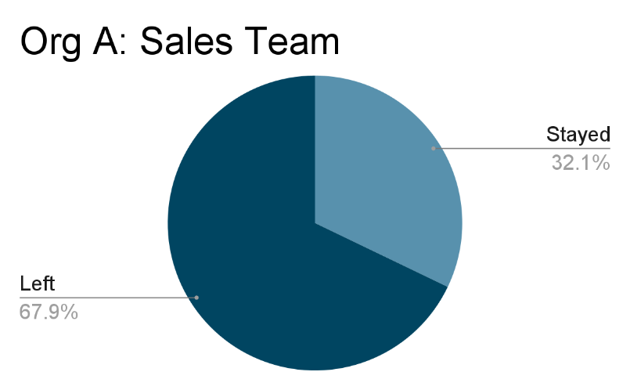

**Org B:** 31.3% (3,571/11,428)

* Highest rate of attrition in Human Resources, Accounting and Technical Departments (all above 25%).

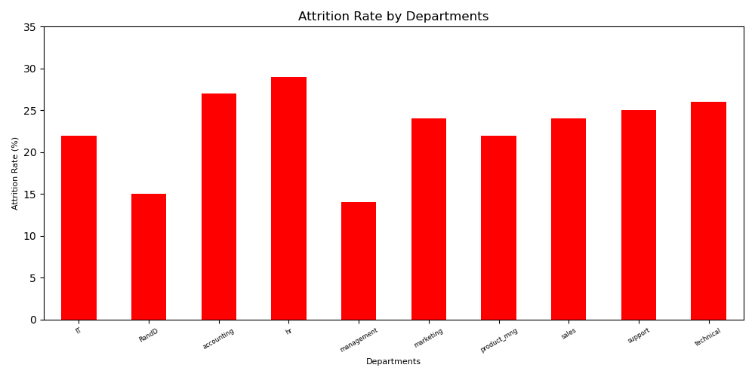

# Who are leaving?

## ……

# Why are they leaving?

## Performance and effort not recognised

Org A:

**Org B:**

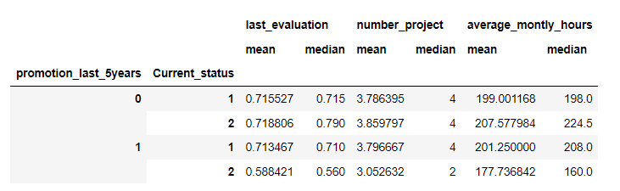

Out of the 3571 employees who left Organisation B, 3552 (99.47% of employees who left) did not receive a promotion in the last 5 years despite their most recent revaluation, average working hours per month, and number of projects allocated being the highest compared to other subsets of employees.

## Impact of workload and job satisfaction on tenure

**Org B:**

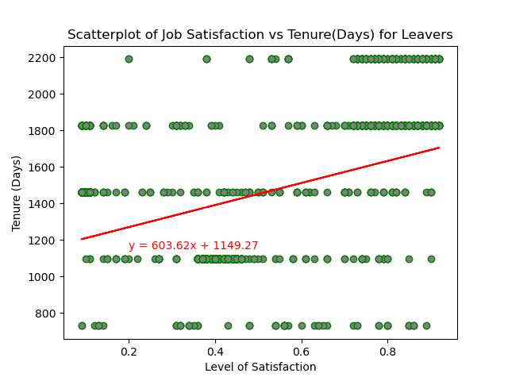

In the dataset for Organisation B, we found that there was a weak but significant positive correlation between the tenure of employees who left and the level of satisfaction they had with their jobs. This suggests that being satisfied with their jobs were important for those who left – given that as job satisfaction increases, tenure increases.

Unfortunately, there was no variable that related to Job Satisfaction in the dataset for Organisation A. Thus, a comparison was not possible.

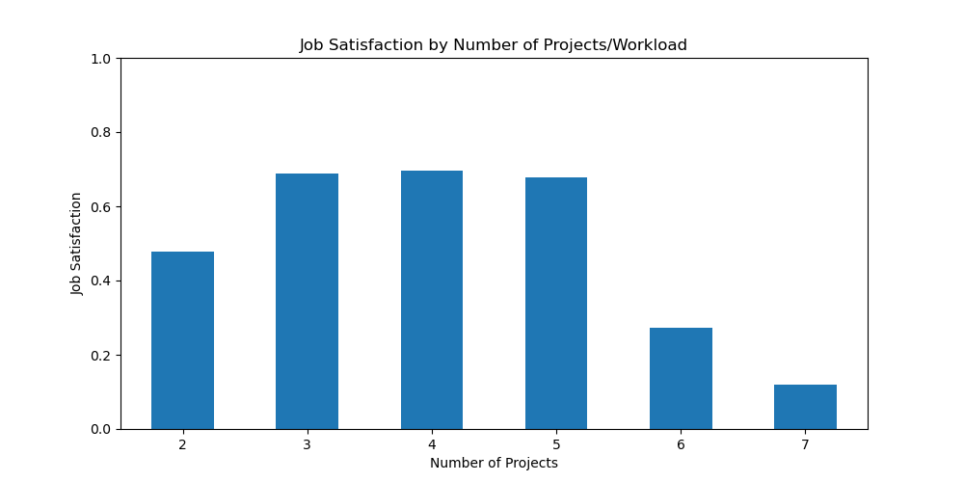

How often have we heard that an excessively heavy workload leads to employees leaving. The data from Organisation B supports this notion as it shows that job satisfaction decreases dramatically when an employee is allocated more than 5 projects.

Interestingly, job satisfaction was also somewhat lower for employees who had only 2 projects. This suggests that being ‘underworked’ also adversely affects satisfaction.

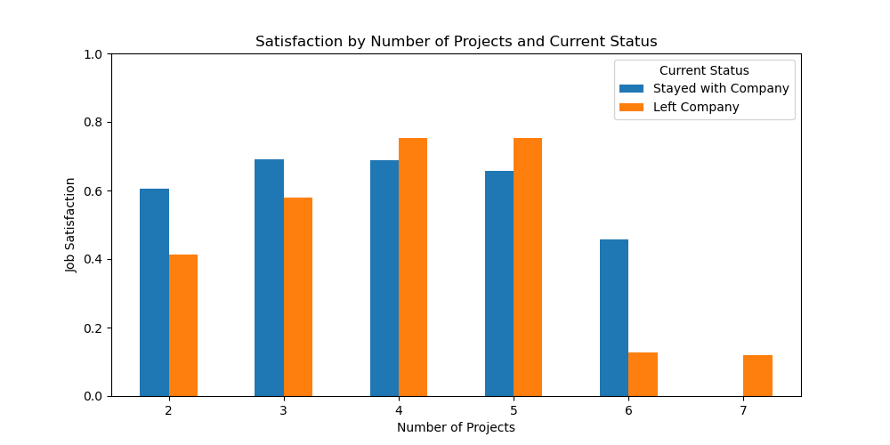

These trends persist when looking separately at current and former employees from Organisation B.

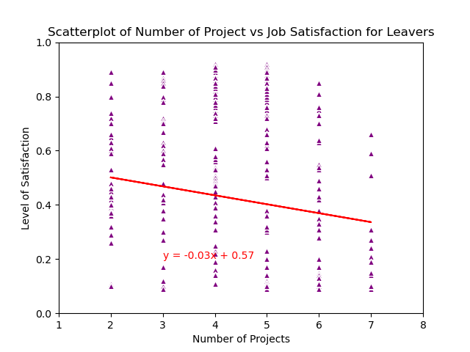

Further analyses revealed a very weak but highly significant negative correlation (-0.23, p < .0001) correlation between ‘Number of Projects’ and Job Satisfaction amongst the employees who left Org B.

This suggests that job satisfaction decreases as workload increases for people who chose to leave Org B. Given the previously observed positive relationship between job satisfaction and tenure, increases in workload can potentially cut short an employee’s stay at a company.

# Implication of Findings

## Recommendations

# Limitations of Analysis

1. Findings and recommendations cannot be generalised to all organisations as specific industries and sectors need to be considered.